**HOW TO INSTALL JAVA DEVEL0PMENT KIT (JDK).**

This document outlines the procedures for installing the Java Development Kit (JDK) and NetBeans IDE.

**Installing Java Development Kit (JDK)**

1. **Download JDK:**

- Visit the official Oracle website or Open JDK site.

- Choose the version suitable for your operating system.

- Download the installer.

2. **Install JDK:**

- Run the downloaded installer.

- Follow the on-screen instructions.

- Set the installation path (default)

- Complete the installation process.

3. **Set Environment Variables** (Windows):

- Right-click on 'This PC' and select 'Properties'.

- Click on 'Advanced system settings'.

- Click on the 'Environment Variables' button.

- In the 'System variables' section, find the Path variable and select it.

- Click 'Edit' and add the path to the bin folder of the JDK installation (e.g., C:\Program Files\Java\jdk-XX\bin).

4. **Verify Installation:**

- Open Command Prompt.

- Type java -version and javac -version to verify the installation.

**Installing NetBeans**

### ****Step 1: Download NetBeans****

Go to the official NetBeans website: NetBeans Downloads.

Select the appropriate installer for your version of Windows and click to download the installer.

### ****Step 2: Run the Installer****

Once the download is complete, locate the installer file.

Double-click the installer file to run it.

Follow the on-screen prompts. You'll need to:

Accept the license agreement.

Choose the installation directory (the default is usually fine).

Select the components you want to install (the default selection is typically recommended)

### ****Step 3: Configure NetBeans****

After the installation is complete, open NetBeans.

Go to Tools > Java Platforms to ensure that the JDK you installed is recognized and selected.

### ****Step 4: Verify Installation****

To verify that everything is set up correctly, you can create a simple Java project.

Go to File > New Project.

Select Java in the project categories and then Java Application.

Follow the prompts to create your new project.

Write a simple Java program to test the environment, like:

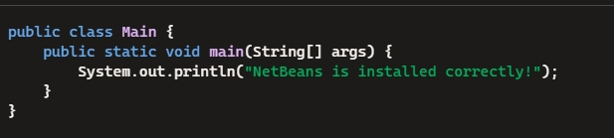

Run the program by clicking the green "Run" button (or pressing Shift+F6).